User ID /Password agfO{;Sg' eof] eg] cf¤km}n] s/ r'Qmfsf] k|df)f kq lgsfNg ;Sg'x'G% .
User ID :- :yfoL n]vf gDa/
Password :- :yfoL n]vf gDa/
ca cf¤km}n] s/ r'Qmf lgsfNg]
s/ r'Qmf lgsfNgsf] nflu
    - www.ird.gov.np
    - s/bftf kf]^{n
    - General
    - TaxPayer Login
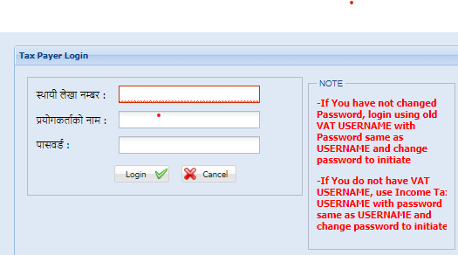
3 j^} sf]&fdf :yfoL n]vf gDa/ /fVg]
- Login df Click ug]{
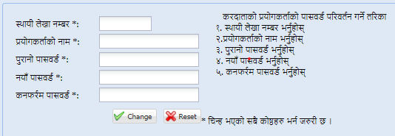
dflysf] klxnf], bf>f] / t]>f] aS;df :yfoL n]vf gDa/ /fVg] / af¤ls 2 j^fdf cf¤km'n] ;Demg ;lhnf] nfUg] gof¤ Password /flv
- Change df Click ug]{
ca tnsf] aS;df 2 j^f aS;df :yfoL n]vf gDa/ kf;j*{sf] aS;df gof¤ kf;j*{ /flv Login df Click ug]{ .

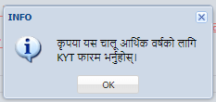
ca klxnf KYT eg'{; df]jfOndf cfPsf] OTP Code nfO{ ok ug'{; -klxnf KYT gel/ s/ r'Qmf lgsfNg ldNb}g_

ca Tax Clearance df Click ul/ h'g cf=a=sf] s/ r'Qmf rflxg] xf] ;f] cf=j= Select ul/ s/ r'Qmf Print ug'{; .

